CHROMOSOME STRUCTURE
By Yogeshwari Tiwari
Department of Biotechnology
Govt. Digvijay Autonomous P.G. College, Rajnandgaon

INTRODUCTION
In humans, 46 chromosomes are arranged in 23 pairs, of which 22 pairs are autosomal chromosomes, and 1 pair is known as the sex chromosome.
Chromosome is a combination of two words – Chroma = colour
Some = body
So, colour threads like bodies are present in the nucleoplasm of the living cells.
They play a vital role in cell division, heredity, variation, mutation, repair, and regeneration.
In eukaryotes, genetic material is present in the nucleus, which is highly organized and compact with histone protein.
History
Karl Negeli (1842) observed chromosomes as rod-shaped bodies in plant cells.
W. Waldeyer, in 1888, coined the term “Chromosome.”
Walter Sutton and Theodor Boveri in 1902 suggested that chromosomes are carriers of genes.
Composition
Protein - 60%
DNA – 35%
RNA – 5%

Size – the size of a chromosome is measured in the metaphase of mitosis.
Plant chromosome length – 0.8 -7 micrometers
Animal chromosome length – 0.5 -4 micrometers.
Shape – shape of chromosome is determined by the position of the centromere –

s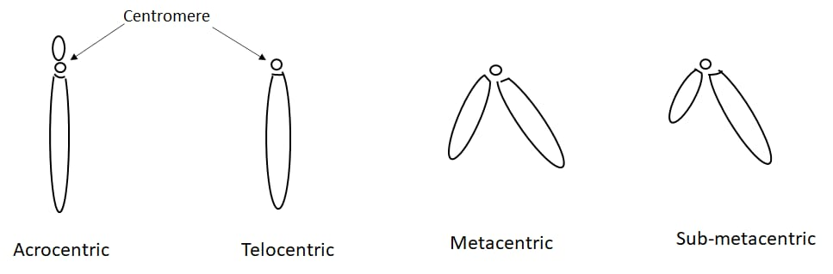

Structure of a chromosome
Structurally chromosome consists of the following parts –
Centromere – a specific region of a chromosome
Made up of a DNA sequence and an associated protein.
Chromatid- structural and functional unit of a chromosome.
When centromeres divide, the chromatids become separate chromosomes.
Arms (p and q): The sections of the chromosome extending from the centromere; the short arm is 'p', and the long arm is 'q'.
Kinetochore: A protein structure on the centromere where spindle fibers attach to pull chromatids apart.
Telomeres: Repetitive DNA sequences at the very ends of the chromosome that protect it from degradation and fusion.
Secondary Constriction: Other constrictions on the chromosome, often containing genes for ribosomal RNA (Nucleolar Organizer Regions or NORs).
secondary constriction helps in nucleus formation.

Chromatin: The complex of DNA tightly wound around histone proteins, forming the basic material of the chromosome.
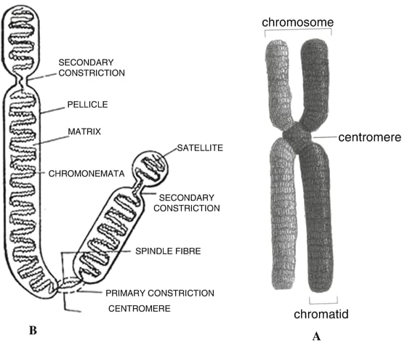

Fig. Ultrastructure of a chromosome
Function of a chromosome
Regulate the proteins of cells.
Determine the gender of an individual.
Contain genetic instructions to control cell processes.
Responsible for variation.

